## Background for the Exercise:

This is a contract for Mail Delivery to our troops in Afghanistan. The routes are treacherous, and they require that vehicles move in convoys, with a U.S. Citizen accompanying the mail. Tampering with the mail is a Federal offence, and it has to be protected – sealed from the place it gets loaded into a connex, to the U.S. military base at the destination. Convoys have to carefully plan the routes, cross hostile territory – and even under attack, they have to save the mail, and get out.

## Assignment:

Turn the table on pages 2-3 into a graphic.

## Proposal Draft:

## 2.4 Location of Checkpoints Along the Routes Used for Delivery

Based on our extensive experience in convoy security operations in Afghanistan on other contracts supporting the U.S. Government, Team Ursus is already organized and prepared to deliver a full range of services to meet the high performance standards mandated in the PWS for Convoy Security. One of these requirements is to establish checkpoints along the routes. We already have a number of checkpoints along the routes because of our existing work in Afghanistan, and we will add additional checkpoints for this contract.

**[PWS 3.2.1.1, 7]** Our Convoy Manifest that we will provide to the APO prior to leaving with the mail, along with other required items such as the route plan, will include the list of our checkpoints. **Figure 2.4-1** shows a notional representation of the critical points along a typical delivery route, as well as the decisionmaking process as to how to proceed along each route safely.

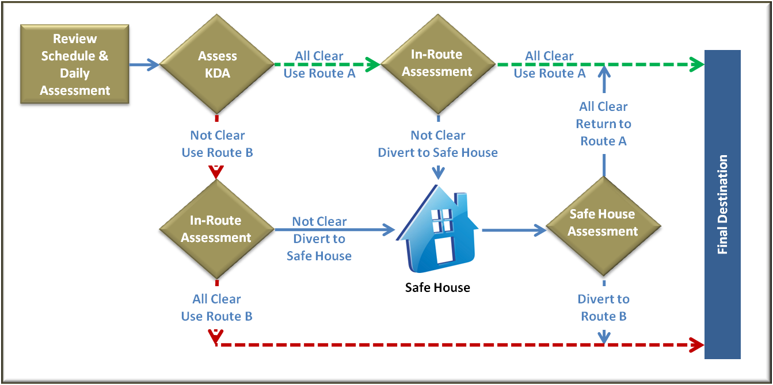

Figure 2.4-1. Critical Points Along a Typical Delivery Route**.** *Our Convoy Escort Team (CET) Leader will make assessments on decisions on how to proceed along each route ahead of the mission and during the mission. He will report as he meets the checkpoints to ensure safe operations.*

Should any CET team fail to meet mission checkpoints, fail to report or come under duress, the PMO will immediately activate an emergency action plan and employ the Quick Reaction Force (QRF) assets. This will include armed assets, medical personnel, and additional vehicle recovery equipment, if necessary.

**[PWS 3.1.6, 7.0]** Our security measures, discussed in Section 1.3 (such as changing routes based on HUMINT, additional vehicles, extra personnel and guards, and other measures) will enable us to minimize the likelihood of such occurrence. Should it somehow become necessary, we have a set of standard recovery plans that we will adjust based on the circumstances. Our security personnel will work with our PMO personnel to coordinate the recovery missions.

**[PWS 3.1.6, 7.1, 7.3, 7.4, 7.5]** We have a detailed plan for four types of scenario for recovery operations, as detailed in **Figure 2.4-2**.

|  |
| --- |
| **1. When the vehicle fails or is in an accident where the connex is intact:** |
| * Notify the COR via the PMO * Have the backup crane available, remove the flatbed with the connex, and put it on the recovery vehicle * Ensure the recovery vehicle is locked onto the spare truck * Return on a scheduled route and call in for a spare recovery vehicle * CET Leader must check that the mail seal is un-tampered with * Our CET Leader, along with our security detail, must ensure full security of the mail connex while it is being shifted onto a new truck |
| **2. When the vehicle is in an accident and the integrity of connex is compromised and mail has dispersed:** |
| * The CET Leader reviews the Mail Manifest and assesses the amount of mail in the connex and moves to account and recover that amount of mail listed in the Mail Manifest * The CET Leader secures the mail and informs the COR via the PMO * In addition, the CET Leader informs the closest military postal office (MPO) * Once the mail is secured, the CET Leader delivers the mail to the appropriate MPO in coordination with the COR |
| **3. When the vehicle is under attack, the connex is compromised, and mail has dispersed:** |
| * Establish a security perimeter around the mail * Activate the Panic procedures on Tapestry system * Notify the COR via the PMO * Deploy Quick Reaction Force (QRF) assets. This will include armed assets, medical personnel, and additional vehicle recovery equipment (if necessary). * Have the backup crane available, remove the connex, and put it on the recovery vehicle * Ensure the recovery vehicle is locked on to the spare truck * Return on a scheduled route and call in for a spare recovery vehicle * Search the accident/incident area to recover everything down to the mail fragments, and deliver them to the nearest MPO * Our CET Leader, along with our security detail, will ensure full security of the mail connex while it is being removed and placed onto the truck * Inventory the mail |
| **4. When the vehicle is under attack, and the convoy receives significant damage:** |
| * Establish a security perimeter around the mail * Activate the Panic procedures on Tapestry system * Notify the COR via the PMO * Deploy QRF assets, including armed assets, medical personnel, and additional vehicle recovery equipment (if necessary) * Recover the mail that can be recovered * Destroy the mail in place if it cannot be recovered in accordance with DOD 4525.6M and SOPs as approved by the COR |

Figure 2.4-2. Highlights of Our Detailed Procedures to Recover the Mail**.**