**1.0 Technical Capability (Preparation Instructions C.3.a.2; Evaluation Factors c.(2) Factor 1, Element A)**

Acme is a trusted partner to CASCOM, with a core competency in OE and the capability development process. In addition to the optimal team, ***Acme brings a number of value-added resources to this requirement, including:***

* Industry-leading expertise in energy technology Research & Development (R&D) from internal open source research and data archive;
* A data-rich methodology to drive better analytics and assessments; and
* Proven current stakeholder relationships to synchronize CASCOM’s mission with the rest of the Army and DOD (currently more than 15 organizations)

TRADOC assessed the future Operational Environment of 2009-2025 to be increasingly expeditionary in nature, with increasing distributed operations presenting serious challenges to traditional logistics support. We’re currently coordinating with 10th Special Forces Group to increase their capability through OE solutions for their current mission in Central Africa. Col. Andrew McCauley, CASCOM OE Office Head, reinforced this dynamic recently in an interview stating “*The bottom line is that we are working to reduce* our *energy footprint to free these assets for other missions, extend operating distance, increase loiter time and operational endurance, and reduce risk, both personal and fiscal.”*

Our diverse multi-disciplinary background shapes our technical and organizational approach. We designed an optimal organizational structure that aligns personnel capabilities with the performance work statement (PWS) requirements. Figurebelow concentrates our technical solution around the 4 key tasks required by the CASCOM OE Office. Our flat organizational structure will leverage synergies across our entire team to collaborate as needed for all four tasks.

**Figure 1.0-1.** **Operational Construct.** *Acme will support CASCOM with OE support through four primary tasks outlined in the graphic to the left. The following sections will demonstrate our technical competence and mission oriented approach to each task rooted in current relevant experience.*

This construct ensures we meet our core team mission of developing valued operational energy concepts and products for the CASCOM Operational Energy Office and its customers. The details of our approach are outlined in the sections below. ***Acme offers high operational relevance to CASCOM in order to better inform the Joint Capabilities Identification and Development System (JCIDS) process.***

## Administrative

PWS 3.0, 3.1; CDRLs A001 – A004, A006, A013 – A020

**Understanding of the specific task:**

**Hybrid warfare** is a [military strategy](http://en.wikipedia.org/wiki/Military_strategy) that blends [conventional warfare](http://en.wikipedia.org/wiki/Conventional_warfare), [irregular warfare](http://en.wikipedia.org/wiki/Irregular_warfare) and [cyberwarfare](http://en.wikipedia.org/wiki/Cyberwarfare).[[1]](http://en.wikipedia.org/wiki/Hybrid_warfare#cite_note-nextgov-1) In addition, hybrid warfare is used to describe attacks by [nuclear](http://en.wikipedia.org/wiki/Nuclear_warfare), [biological](http://en.wikipedia.org/wiki/Biological_warfare) and [chemical](http://en.wikipedia.org/wiki/Chemical_warfare) [weapons](http://en.wikipedia.org/wiki/Weapon), [improvised explosive devices](http://en.wikipedia.org/wiki/Improvised_explosive_device) and [information warfare](http://en.wikipedia.org/wiki/Information_warfare).[[2]](http://en.wikipedia.org/wiki/Hybrid_warfare#cite_note-Information_Week_Government-2) This approach to [conflicts](http://en.wikipedia.org/wiki/War), is a potent, complex variation of[warfare](http://en.wikipedia.org/wiki/Warfare).[[3]](http://en.wikipedia.org/wiki/Hybrid_warfare#cite_note-3) Hybrid warfare can be used to describe the flexible and complex dynamics of the [battlespace](http://en.wikipedia.org/wiki/Battlespace" \o "Battlespace)requiring a highly adaptable and resilient response.[[1]](http://en.wikipedia.org/wiki/Hybrid_warfare#cite_note-nextgov-1)[[2]](http://en.wikipedia.org/wiki/Hybrid_warfare#cite_note-Information_Week_Government-2)

Probably the most recent example of hybrid warfare would be that of the performance of [Hezbollah](http://en.wikipedia.org/wiki/Hezbollah) in the 2006 Lebanon War. During this conflict, Hezbollah fought the Israeli military to a standstill by engaging them from either concealed, fixed positions and underground tunnel complexes (emulating the [Viet Cong](http://en.wikipedia.org/wiki/Viet_Cong)) or by conventional infantry combat maneuvers in Lebanese villages. The outcome of these tactics were that the [Israel Defense Forces](http://en.wikipedia.org/wiki/Israel_Defense_Forces) failed to conquer a single village along by the Israel-Lebanon border, in the time of its two-week ground assault on Hezbollah. Israel's greatest strengths, namely having a modern and capable armoured corps and air force, were nullified by Hezbollah fighters utilizing hardened bunkers and modern Russian ATGMs, capable of destroying any known type of armoured vehicle. At one point, Hezbollah utilized an anti-shipping cruise missile, [C-802](http://en.wikipedia.org/wiki/C-802), to severely damage the corvette INS Hanit and kill four Israeli sailors on board.

This was combined by Hezbollah succeeding in hacking into Israeli communication and Israeli soldiers' mobile phones to receive first-hand knowledge about enemy troop movements, communications and casualties.

In order to develop valued capability concepts and products, we must first and foremost keep the CASCOM team inherently tied to and synchronized with all its customers and other key operational energy stakeholders. Thus, the Acme OE team will be present for all OE-related forums to include conference calls, Video Teleconferencing (VTC), and other meetings that require CASCOM participation. We currently support similar meetings at the Pentagon, U.S. Army Training and Doctrine Command (TRADOC), CAC, ARCIC, and Research, Development, and Engineering Command (RDECOM).

We proactively support our clients in improving stakeholder engagement through such meetings and forums including the Operational Energy Working Group, conferences, VTCs, conference calls, interagency meetings, and site visits to technologies, labs, and installations both in CONUS and in theater. We bring a keen sense from the Defense community at large that is relevant or interested in OE to best position CASCOM as a thought leader and value-added partner for developing the Army’s OE capabilities. We understand the Army planning, capability development, and staffing processes require active participation, administrative support, tracking and completing tasks, and milestone analysis to ensure strategic plans are on schedule. Administrative tasks can include updating stakeholder analysis, Point of Contact (POC) lists, attendance confirmations, Audio-Visual (AV) and tech support, printing, and follow up due-outs or specific tasks. Outputs can include Interface Control Documents (ICD) and Capability Development Documents (CDD).

Army and Joint logistics and operations doctrine has been the “lens” we use in viewing OE since the beginning. For this reason, we closely support the Army G4 in our current OE efforts and always coordinate primarily with the Commander for logistics in any exercise or AOR that we’re involved in. We have significant experience in full spectrum logistics and are demonstrating our thorough understanding of the Army and Joint logistics operations framework via our contract work in executing the Rapid Equipping Force “Energy to the Edge” program in several Army operational environments abroad, to include Afghanistan. We collaborate with G-4, ARCIC, RDECOM, RDECOM Field Assistance in Science and Technology Center (RFAST-C), Project Manager Mobile Electronic Power (PM-MEP), Product Manager – Force Sustainment Systems (PM-FSS), OEPP, Logistics Innovation Agency (LIA), DOE, and various logistics headquarters in a particular operational environment.

To stay well-informed and standardized across our energy practice, we developed and routinely

update our internal standardized training that consists of a required reading list, short exam, and

professional development plan. To date, this has always included an emphasis on logistics and

energy. Required references and reading include FM 3-0, FM 701-58, FM 3-05.140, FM 700-80,

DLA’s DLMS, JP 4.0, FM 100-5, and OSD’s Operational Energy Strategy and Implementation

Plan, Task Force on Emission Inventories and Projections (TFEIP), TARDEC’s

Grounds Systems Power and Energy Laboratory, CASCOM Key Performance Parameters,

ARCIC Power and Energy White Paper, Defense Science Board Energy Task Force,

TRADOC Operational Environment 2009-2025, and the Army’s Energy

Security Implementation Strategy.

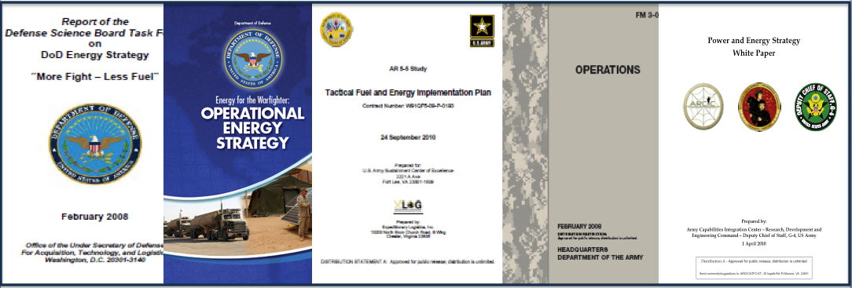

Figure 1.1-1. Sample Required Reading. Acme data collection includes the regular updates and lessons learned guiding Operational Energy at the tactical, operational, strategic and policy levels.

Full spectrum logistics ensures Army operational dominance over our adversaries. Our Soldiers are equipped and sustained in all phases of war fighting operations, to include all phases of stability operations. Army sustainment includes a seamless logistics system, distribution-based logistics, total asset visibility, agile infrastructure, rapid force projection, and an adequate logistics footprint to supply Adaptive Brigades and Brigade Combat Teams from early entry operations to ultimately their efficient re-deployment. Successful full-spectrum sustainment operations ensure all Soldiers and their equipment maintain an appropriate combat readiness at any time to meet our nation's challenges. At the Joint level, full spectrum logistics must also ensure operational dominance over our adversaries. Thus joint sustainment models must include additional tenets for our leaders to emplace with a joint force in any part of the world. Such tenets include joint theater logistics command and control, joint deployment and rapid distribution, multinational logistics, joint health services support, information fusion, and agile infrastructure. The Joint Sustainment Model ensures all our allies and partners are equipped and sustained in a manner that guarantees a successful outcome via efficient application of logistics enablers.

**Ability and methodology to meet the minimum requirements:**

Acme, through the Rapid Equipping Force (REF), is currently developing the new Program of Instruction (POI) for ARCIC on OE. Our technical competence in OE and current projects across the Army offer unique value to CASCOM and its OE objectives.

Acme brings institutional expertise in OE concept development that includes the first U.S. Marine Corps (USMC) Experimental Forward Operating Base (ExFOB), Net-Zero Plus, multiple Joint Capability Technology Demonstrations (JCTD), Smart Power Infrastructure Demonstration for Energy Reliability and Security (SPIDERS), Energy to the Edge, Power Surety Task Force, and the Office of Operational Energy Plans and Programs (OEPP).

Our program management team can author, staff, and brief OE concepts and capability documents and brief them to the highest levels of Army, OSD, and Joint staffs. Our proposed OE Program Manager, Joe Smith, has focused recently on solar and wind technology for OE and bring relevant previous CASCOM experience to this team. The Alternate PM, Mr. James Bond, will complement the PM with recent relevant OE support from several COCOMs this year and supporting ARCIC through the REF. This management combination ensures proven capability development support to CASCOM with recent relevant operation insights.

As a small business that relies on collaboration and efficient management processes, our on-site team supporting CASCOM will benefit from corporate OE expertise, resulting in a synergistic effect and value added capacity for the customer. Acme has the expertise in leveraging collaborative environment software tools such as SharePoint to pull together all the organizational elements’ inputs and tie their unique perspectives and language and work products into a synchronized capability development and feedback loop that enters into the JCIDS process at the right point. Several of the concepts identified above required JCIDS documentation, such as the August 2012 Operational Needs Statement (ONS) that was just approved.

We know how to apply the capability-based approach to developing requirements through the JCIDS process. We’ve helped a variety of Army organizations through this requirements needs analysis that support the PPBE process of allocating resources appropriately against such requirements.

Having supported OE for the USMC, Joint, and Multinational forces, Acme will apply JCIDS to help focus on joint concepts and integrated architectures:

1. Through the capability-based analysis, identify joint gaps based on likely emerging threats or a new vulnerability;

2. Apply Doctrine, Organizations, Training, Materiel, Leadership & Education, Personnel, Facilities (DOTMLPF) analysis to ensure our solution space is all-encompassing in developing capabilities; and

3. Leverage the JCIDS process for the right insertion point for any potential material solutions that can accelerate the acquisition effort if a material item provides the desired capability.

For example, compelling DOE research that may be conducted within the focus of the Army OE Campaign Plan or ongoing COCOM experimentation must still be vetted against Army and Joint Force Sustainability methods and requirements.

This is a different entry point when compared to mature industry technologies for OE that possess a higher Technology Readiness Level (TRL) and might be inserted in a PM or Rapid Equipping Force limited operational demonstration if the requirement has matured.

Acme will support the CASCOM OE Cell to fuse these concepts, needs, analysis and technology solutions into a capabilities-based Army integration effort that assists and informs ARCIC, TRADOC systems managers, Army Staff (G-4, G-8), and PMs in fulfilling the requirement, if in fact a material solution is needed. We will then match it to the DOD program and planning execution cycles so that appropriate near-, mid- and long-term resources can be obtained to support the Army OE vision. We understand this process and bring proven success in executing more than 30 OE concepts and solutions. Our organizational concept leverages existing relationships.

Extent to which uncertainties are identified and resolutions proposed is shown in **Table 1.1-1.**

**Table 1.1-1.** Risks and Mitigations.

|  |  |  |
| --- | --- | --- |
| Risk | Rationale | Acme Mitigation |
| **Relevant only for yesterday** | Rapid technology evolution, timing of budget and programming cycles, innovation from other services and agencies, | * We foster collaboration and open source innovation using 6 different research tools to stay on the cutting edge of technology development and best practices |
| **Risk in the management team** | Leadership will greatly impact this program and CASCOM’s success. Other management may not be secured or be able to ensure the required operational insight. | * Entire management team is currently employed at Acme * The Quality Manager, principal in the firm, will personally guarantee the program’s success |
| **Inefficient program staff or contractor** | Un-necessary management hierarchy in companies and subcontractors create inefficient project execution and lack required flexibility and timeliness this program needs | * Contract authority delegated on-site with proven PM * No subcontractors and efficient collaborative model from recent relevant programs in scope and complexity |

#### Skill Mix for the Task

Acme will bring the optimal combination of skills and experience level to effectively and efficiently support CASCOM in this task.

**Table 1.1-1.** Skill Mix for the Task.

|  |  |
| --- | --- |
| Labor Category | Number of Hours |
| Program Manager | **100** |
| APM/SME | **750** |
| PPBE/Integration Lead | **220** |
| Capabilities & Integration Manager | **200** |
| OE Analyst | **120** |
| Tech/Analysis Chief | **250** |

#### CDRLs Associated with This Task

**Table 1.1-2.** CDRLs.

|  |  |  |  |
| --- | --- | --- | --- |
| CDRL Number/Title | Due Date | Performance Standard | Development Notes |
| A001 – Quality Control Plan (QCP) | Draft within 30 calendar days after award and final within 5 days of receipt of the changes | Free of serious defects | Our PMP certified QAQC Manager will brief the QCP in person with hard copies and QCP procedures and benchmarks on the project SharePoint site. He is an OE SME as well to ensure quality and effectiveness of all deliverables. |
| A002 – Program Management Plan (PMP) | 10 days after Contract Start Date | Free of serious defects | We have already developed a draft PMP. Key elements of the PMP include the following:   * Program Chain of Command * Task-focused Organizational Construct * Requirements Management Plan Excerpts * Agile Management Practice   Some of our key strategies include hiring and empowering a strong leadership and management team and establishing an organizational model that allows us to focus on the specified tasks and affiliated requirements. |
| A003 – Monthly Status Report | Within 10 days of the period reported on | Free of serious defects | Joe Smith, the PM, and/or James Bond, the APM, will provide the CASCOM OE office a written monthly report in a briefing and narrative format. It will provide general officer leadership an In-Progress Review of our team’s efforts, key learning points, updates of tasks and milestones reached, and issues needing resolution regarding our performance of the OE support contract.  We will glean this information from internal daily and weekly compiled Situational Reports (SITREPs) as part of our internal quality management effort and internal work documentation effort. We will structure the information to facilitate continual key and senior leader education regarding the OE work effort. We will also ensure past work is on track and future work focus is appropriate and in line with senior leadership guidance.  Joe Smith will attend the In Progress Reviews (IPR) with the COR and other customer leadership. |
| A004 – OE Concepts, Plans, Meeting Minutes, and JCIDS Documents | As requested, approximately 20 1-2 page documents per month | Free of serious defects | The Acme Team’s Capabilities and Integration (C&I) Branch will analyze existing and emerging Army ONS documents, as well as other Service and Joint requirements documents regarding OE concepts and development. It will compile this information in a manner that informs our Capabilities Development effort.  The lead for this work effort will be the C&I Branch Chief. The C&I Branch Chief will conduct bi-weekly Integrated Process Team (IPT) meetings with doctrinal staff at Army Centers of Excellence, as well as Army CENTCOM Engineer and Sustainment leads at Army Central (ARCENT) and related SMEs at other Service and COCOM agencies. This will help ensure we approach this effort informed by Joint doctrine but mindful of Army’s current and future sustainment objectives regarding OE and the Army Campaign Plan guidance for reduced supply demand signals. |
| A006 – CASCOM OE Cell | Within 30 days after start of contract | Cell contains all required subject matter expertise | Our six-person, two-division OE Cell is organized to handle all phases of the contract. This incorporates capabilities development and JCIDs work via the Capabilities and Integration Branch, as well as data collection and analysis of experiments and ongoing Warfighter forums. These include emerging and existing technology reviews of appropriate energy efficiency, renewable energy, water conservation, and energy storage technologies.  Our Program Manager and Alternate Program Mangers have the requisite military OE experience, as well as solid military perspective from deployments to various wars and civilian experience in sustainable energy technologies, policy, and doctrine.  Collectively, the Acme team, when augmented with our PPBE Manager that also has Operational Energy experience at the Joint level, will excel in supporting the existing CASCOM OE team. We can immediately bring data and technical knowledge to further inform the AOECP in depth while simultaneously keeping other TRADOC Centers of Excellence (CoE) decidedly engaged in our effort through the use of Acme collaborative tools. |

1.2 Study and Analysis

PWS 3.2, CDRLs A006, A009

**Understanding of the specific task:**

DOD and the Army have evolved their thinking regarding OE given the current variety of environmental factors and emerging threats, and innovations in clean, renewable, and efficient energy. ARCIC’s OE White Paper was the first step in informing the development of the Army’s OECP. We know how logistical planning considerations and metrics for OE are integrated in the revised Army Functional Concept Framework (AFCF). Our team of former military officers has participated in more than 10 deployments in and out of uniform since 2001.

We have seen firsthand the human and platform impacts that extended lines of communication have on our current sustainment model. Team Acme has led a persistent campaign since 2006 in tirelessly communicating to senior Army and Joint leaders that ***in hybrid warfare we need to leverage rapid technology insertion of sustainable Commercial Off-The-Shelf (COTS) and Government Off-The-Shelf (GOTS) technologies to significantly reduce energy and water demand signals in the operational environment***.

The results we have demonstrated both in CONUS and in Afghanistan, as well as other parts of the world, enable tactical commanders to enjoy longer mission endurance and greater freedom of action. However, OE work must be approached from a more efficient mass and energy balance concept. It requires a full DOTMLPF analysis and full CASCOM engagement to truly gain the greatest operational efficiencies and thus meet sustainment objectives as communicated in TRADOC Pam 525-4-1. ***As outlined in the AFCF, Acme stresses the importance of supporting the most austere environments by physically being there in order to best inform future Army force development.***

We supported the Army at OCPA as the ACP was approved and issued earlier this year. We’ve been working closely with ARCIC in its guidance for OE and currently participate with CASCOM at the Army OE Working Group.

Acme currently produces more than 800 analytical reports for OCPA and U.S. Army Medical Command (MEDCOM) annually. Similarly, our OE advisors have produced dozens of strategic studies and analyses focused on the most pressing OE issues of the day.

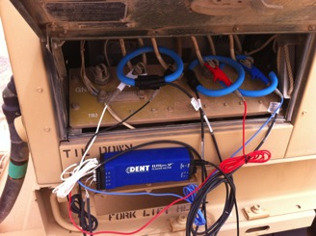Data collection is critical to this task of supporting studies and analysis. To accomplish this task, we will continue to leverage information gained from our existing relationships with the currently deployed task forces. CASCOM gains real-time feedback on what is really happening on the OE front in Afghanistan and other operational environments across the globe with the Army as well as the U.S. Central Command (CENTCOM), U.S. Southern Command (SOUTHCOM), U.S. Africa Command (AFRICOM), United States European Command (EUCOM), and International Security Assistance Force (ISAF).

In addition to the individuals directly assigned to this project, Team Acme possesses deep corporate expertise in intelligence collection and analysis, organizational assessment, and relevant social and behavioral sciences. Acme has a proven track record and past performance in data collection and fusion, analysis, and command recommendations. We have done this type of work at the Service, Joint, and National levels of command. Our experienced staff will work under an OE Program management leader and organizational structure to address all study and analysis performance work requirements and deliverables.

In support of baseline assessments and OE measurement, Acme introduced data loggers to reliably measure against key indicators.

**Ability and methodology to meet the minimum requirements:**

We will provide scientific, technical, and professional expertise through our staffing solution that includes Army and Joint logisticians and OE advisors. We will enable their collective insights through data management solutions and tools, visualization, and open source information to maintain their expertise in these fields. We currently provide this support in the context of the Army Functional Concept Framework, ACP, ARCIC, and TRADOC guidance, and will continue to do so. Our active and passive data collection methodology describes how our staff will research, analyze, and draft products. Our significant inflow of information, and understanding how to manage it as an integrated team, will streamline our production process for concept papers, briefings, and white papers on Capability Based Analysis (CBA) that lead to DOTMLPF Integrated Capabilities Recommendations (DICR).

Our ***robust current and historical data collection and market research will inform our team supporting CASCOM, and provide an unparalleled relevance to the OE Cell and OE capability development***. We will use active and passive data collection to maintain subject matter expertise on OE for our DOD clients. **Table 1.2-1** outlines our various research methods that have proven effective, are archived, and will add additional value to the team supporting CASCOM. We will share and archive all insights and lessons learned within our OE database.

**Table 1.2-1.** Research Methods.

| Method or Source | Passive/  Active | Benefit |
| --- | --- | --- |
| ***Conferences/***  ***events*** | Active | Acme regularly attends or speaks at leading OE-relevant forums and conferences, including NDIA’s E2E, Arizona State University (ASU), Virginia Tech, GovEnergy, REF Expo at the Pentagon, Winter and Annual AUSA, and more. |
| ***Academia & National Labs*** | Active | We leverage relationships with several universities and all the National Labs from working together for the last 5 years on OE-related challenges. |
| ***Industry engagement*** | Active | Acme brings due diligence from direct testing for more than 450 technologies to stay on the cutting edge of technological innovations. |

Acme OE staff employed for this work effort includes several former Army officers and NCOs with multiple deployments experience in support of Army and Joint logistics operations, and advanced degrees in engineering. In addition, other staff members possess relevant certificates in areas like basic solar installation, building energy efficiency, civilian electrical installation credentials, and more.

The program management team is comprised of senior managers who have developed numerous products under the Army Functional Concept Framework documentation process. They developed these products for specific support of ARCIC and TRADOC efforts to support the Army Campaign Plan. Acme will leverage at least six tools and data collection methods matured from other work efforts. We will incorporate them into the OE team to provide an analysis and knowledge management framework. This will help ensure CASCOM OE reports are appropriate for application in future force sustainment models for the Army and Joint Organizations.

Our collective experience in all aspects of OE work over the last five years validates the need for the CASCOM OE Team to lead and execute Capability Based Analysis in support of emerging themes for the Army Concept Framework. We will accomplish this task by focusing a rigorous and enduring DOTMLPF work effort in our Technology & Analysis Branch, as shown in our organization chart in **Figure 1.2-1**. The focused outputs will include DOTMLPF Integrated Capabilities Recommendations that TRADOC and Army senior leaders can leverage to inform future *train and equip* programming decisions for Army future force sustainment concepts emerging in the 2016-2028 timeframe. We believe this is a critical task, as current efforts by the various organizational entities in the OE arena are mostly specific in scope and not necessarily connected in end-to-end outcomes. They don’t always result in a more informed effort to integrate OE capabilities that support the Army Campaign Plan. Our approach will ensure quality white papers emerge from CASCOM to appropriately inform senior Army leadership. This information will empower them in making wise programmatic decisions that result in successful future sustainment establishment.

Acme staff onsite at the Pentagon drafted the Assessments Annex of the *Telling the Army Story* campaign, which was added to the ACP. We understand the process from concept development and white papers to Chief of Staff of the Army approval and adding to the ACP.

The JCIDS model of developing concepts, given the desired capabilities via well-thought through DOTMLPF analysis, works to ensure appropriate Force and Material Enablers are in place. This is because the results enable a more fluid approach to train and equip the force based on Army Force Generation (ARFORGEN) models versus individual organizational efforts that are more staccato in nature.

The Acme approach establishes a Capabilities & Integration Branch that complements a Technology & Analysis Branch, as shown in **Figure 1.2-1**. This way, the Technology & Analysis Branch team’s development of all Capability Based Analysis, all warfighter experimentation and lessons learned and integrated Capabilities Recommendations, will seamlessly feed the Capabilities and Integration Branch to further develop CASCOM OE Concepts. This will further mature Capability Integration products for output to ARCIC and JCIDS managers.

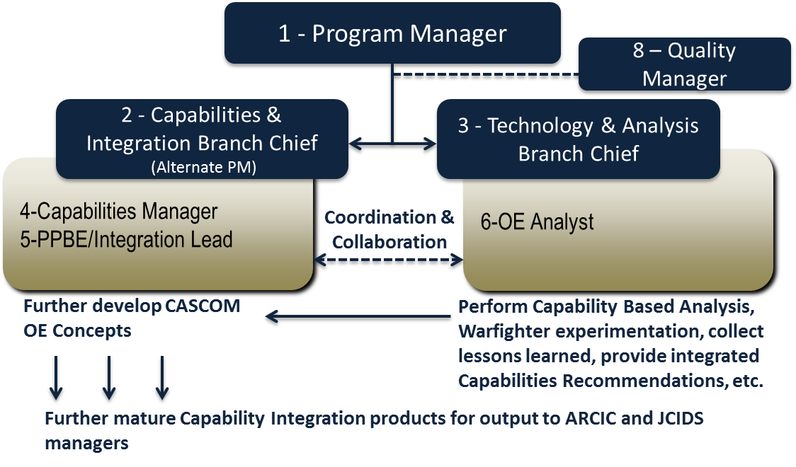

**Figure 1.2-1. Organization.** *The two branches in our OE Cell will enable better outputs to ARCIC and JCIDS managers.*

The two branches in our OE Cell will help the OE PM and the CASCOM OE Team inform leaders about OE products that will support the future force sustainment models, given our inputs to the JCIDS process starting immediately upon contract award. While the Technology & Analysis Branch focuses on high quality study and analysis, the Capabilities & Integration Branch will focus on the JCIDS and DOTMLPF work products to ensure a continuum of informed capabilities development products that consider and enable future TRADOC and if appropriate, Acquisition efforts, to ensure full spectrum integrated OE work that provides commanders the capabilities they desire. As depicted in **Figure 1.2-2**, Acme’s process is rooted in doctrine as outlined in the JCIDS Manual 19 Jan 2012 and leverages our insights and experience with initial capabilities document development.

A new approach to OE is critical, given our evolving Army and Joint sustainment models that are further developing in light of hybrid war scenarios and extended lines of communication and logistics. A well thought-out and JCIDS-focused OE approach is especially critical for our smaller-sized (squad to battalion) Army and Special Operations/Joint formations that require significant platform and security commitments during resupply operations. Only more diligent TRADOC participation via the CASCOM OE Cell will ensure these needs are resourced for sustainment models for the future Army out through 2028. We facilitate service-level capability-based analysis, and DOTMLPF-inspired Integrated Capabilities Recommendations to help accomplish this. An example of such efforts includes the Marine Corps’ ExFOB program and the current round of technology recommendations stemming from that effort.

We will design our data collection, analysis, documentation, dissemination, and archiving activities within a basic framework that expertly accomplishes all tasks specified in the PWS paragraph 3.0 and its sub-paragraphs, and creates flexibility. These factors are key to fulfilling an imperative to derive and answer diverse implied questions, and accomplish tasks that will inevitably arise as new knowledge is discovered.

Extent to which uncertainties are identified and resolutions proposed is shown in **Table 1.2-2.**

**Table 1.2-2.** Risks and Mitigations.

|  |  |  |
| --- | --- | --- |
| Risk | Rationale | Acme Mitigation |
| **Insufficient data to drive studies/analysis** | CASCOM must ensure robust data from all training and operational environs in order to best inform studies and analysis. Contract support must facilitate this operational insight through direct access. | * Current direct feedback and operational relevance from recent experience and access to appropriate data sources. |
| **Lack of current global reach to support emerging range of Army OE issues** |  | * Recent support to EUCOM, AFRICOM, CENTCOM, USFOR-A within a 90-day period. Acme has proven rapid deployment and reach into any AOR to support OE data collection and analysis. |

#### Skill Mix for the Task

**Table 1.2-4.** Skill Mix for the Task.

|  |  |
| --- | --- |
| Labor Category | Number of Hours |
| Program Manager | **750** |
| APM/SME | **250** |
| PPBE/Integration Lead | **400** |
| Capabilities & Integration Manager | **720** |
| OE Analyst | **900** |
| Tech/Analysis Chief | **800** |

#### CDRLs Associated with This Task

**Table 1.2-5.** CDRLs.

|  |  |  |  |
| --- | --- | --- | --- |
| CDRL Number/Title | Due Date | Performance Standard | Development Notes |
| A006 – CASCOM OE Cell | Within 30 days after start of contract | Cell contains all required subject matter expertise | See the development notes provided in Section 1.1. |
| A009 – Unit Power Requirements | 225 days after start of contract | Free of serious defects | Acme is currently collecting and tabulating Army reports regarding real-time operational deployment energy consumption at the small unit level (company and below).. |